COVER PAGE

**FORESIGHT IN CIVIL LAW IMPLEMENTATION**

**NUR ANISAH ABDULLAH**

**Strathclyde Business School**

**University of Strathclyde.**

**nuranisah@gmail.com**

**Foresight in Civil Law Implementation**

**Abstract**

A two-day conference was designed to advance foresight as part of the wider civil servants capacity building initiative. Foresight was engaged with a view to facilitating the stretching of thinking and the creation of a future mental space for participative discourse amongst diverse stakeholders allowing for the exploration and experiencing the implications of the new civil law before they come into being. Is foresight useful in supporting the thinking of and the planning for the implementation of a new law? This paper presents the conference methodology, expands each approach introduced, draws conclusions from participant insights on the functionality of each futures methods.

Keywords

Foresight, Futures, 2X2 scenario matrix, scenario simulation, civil service reform, Civil Law, policy development, policy implementation, strategy development.

**Foresight Promotes Innovative Thinking**

“The Foresight Methodology allows us to think ahead, anticipate potential developments, analyse risks and respond to future eventualities,” Soso Giorgadze, Chairperson of the Public Service Development Agency (PSDA), said, speaking at the opening of the conference.

On June 22-23, 2017, ServiceLab (Innovative Service Laboratory) of the Public Service Development Agency (PSDA), in cooperation with the Civil Service Bureau (CSB) of Georgia, and with assistance from the United Nations Development Programme (UNDP), Government of Sweden and Government of the United Kingdom of Great Britain and Northern Ireland; organised a conference on Analysing Civil Service Reform Using Foresight. The Conference was designed to advance foresight methodology as part of the wider civil servants capacity building initiative for civil service reform agenda.

Over 60 participants attended the conference comprising of Georgian public officers, civil society professionals, representatives of four universities and several international organisations.

UNDP in Georgia aims to:

1. Strengthen the capacity of the Civil Service Bureau (CSB) to implement the civil service component of the Public Administration Reform by providing the staff of CSB with a new strategic planning tool;
2. Raise awareness regarding the new Law of Civil Service of Georgia among the target groups (civil servants, non-governmental organizations and students); and
3. Ensure smooth implementation of the law and the reform component.

In the context of public service reform, the coming in force of the new Civil Law clearly change the management of civil servants, impacting civil work practice and service delivery. Foresight was introduced with a view to strengthen the capacity of the Civil Service Bureau in strategic thinking and planning needed for effective policy implementation.

**Conference Conceptual Framework**

This conference, different from a typical conference of speeches by ‘sage-on-stage’. The conference brought together the intended stakeholders groups creates a platform for engaging multi-agent, multi role participative discourse and experiential foresight in envisioning possible alternatives brought about by the new Civil Law coming in force July 2017.

Throughout the 2-day conference participants were engaged in brainstorming sessions and group activities using trend analysis, postnormal times menagerie analysis was introduced as an approach for horizon scanning for emerging issues and weak signals; 2X2 Matrix for scenario development, and 2X2 simulation was introduced allowing for the experiencing at least one of the four scenarios developed. These methods created a space for participative discourse on the impacts and implications of the new Law. Concerns about the effects arising from the implementation of the new law were raised and discussed by representatives of various ministries explaining how the new law were enacted to address specific issues in public services. While learning the use of foresight for analysis, participations were exploring and gaining a better understanding of the new Law; clarifying and recognising potential causes of tensions in the situation in which the discussions were in fact creating a space of understanding own’s perspectives and those of others’.

The 2-day time frame was thought to be slightly short for a more thorough and comprehensive discussion on the alternative scenarios stemming from the new law and the risks associated with possible reactions from civil servants and the general public.

The conference began with Futures Literacy by prompting these questions :

Why think about the future?

How do we broaden our thinking so that our lives are not limited by the obvious and familiar? (Polak 1971)

**Strategic Foresight**

Foresight is essential to crafting an anticipatory approach to policy, planning, and/or strategy. Foresight suggests that there are always a range of possibilities for what might lie ahead—some of which are more preferable than others. Foresight focuses on analyzing trends, identifying emerging issues, mapping blind spots, navigating critical uncertainties, and creating uncommon opportunities as a means of developing the capacity to be futures literate. While much of foresight deals with adapting to change, it is also a valuable tool for identifying values, traditions, and aspects of the past that ought to be sustained for future generations. As such, foresight emphasises context and focuses on the local as much as the global and regional.

In the case of Civil Service Reform in Georgia, strategic foresight facilitates the analysis of and exploration into the alternative futures for civil service officers as well as how those new laws and regulations might translate into the delivery of public services with the collaboration of ministries and stakeholders. Foresight is most effective when integrated and institutionalised alongside with administration and planning.

**Theory of Social Complexities**

The understanding of futures studies hinges strongly on the Theory of Social Complexities. Complexity refers to the state of a system where we can not deliberately threat any single element as if they each, individually, were not systematically connected. These individual elements hold some kind of relative position within a structure forming a state of a system as a collective whole. One of the essential aspects of a complex system is emergence: the process by which small things can escalate or accelerate into larger phenomena, which often leads to change or disruptions within the system.

Putting this perspective into the process of planning and decision making, complexity requires rethinking our approach in facing the challenges of today and the possibilities of tomorrow. Complexity challenges us to rethink how problems are defined and contextualised while also emphasising the need for more reliable and useful means of data capture and analysis. “While statistics can successfully deal with complex phenomena where elements of the society on which we have information, it can tell us nothing about the structure of these elements or the functioning of those elements” (Hayek, 1994; p60).

Complexity is a key construct to strategic planning which compels the consideration for the broader impacts of each emerging issue; and the longer-term implications of decisions made today. Foresight facilitates the stretching of thinking into such realm.

**Where do you stand? The Polka Game**

One of the best ways of creating an awareness of how we ‘see’ ourselves and how others ‘see’ us is to describe the images of ourselves and others; and listen to others describe the images they have of us. As an ice-breaker and an opening exercise, participants were asked to play the Polak Game - Where do you stand? The game was based on Polak (1971) seminal work, the Image of the Future. Where Do You Stand- presents as a two-dimensional matrix: (i) the degree of happiness/misery, and (ii) the cause of happiness/misery- people versus system creating four quadrants, namely ‘happy-system’; ‘happy-people’; ‘sad-people’ and ‘sad-system’, see Figure 1.

Figure 1: Where do you stand? - The Polak Game. <insert here>

Man forms and holds images of ourselves and others, of our own group and of other groups; and that public images of the future can be changed and re-constructed for a preferred-larger social and cultural processes. Any attempts in shaping those change, the images that already exist in the minds of the society must be examined to better understand the extent of possible influence on decisions; and if these influences were deemed less desirable, what needs to be done to re-direct them? (Polak, 1973; p14-15).

Participants in each quadrant took turns to describe how they felt and what made them felt and behaved the way they did. After completing that each group talked about their reactions towards the descriptions of others — their opinions on the worldview of others. The game ends with the group that successfully convinced others to join them in their zone (quadrant).

The game allows for an experience (Kolb, et al., 2000) of being in a specific state and a lense into understanding oneself and others. Polak (1973) suggests that “the minds of men were prepared for discoveries and different views of the world” (p99). This ability is crucial for one to realize that people do have different and diverse worldviews due to various reasons, and that differences and diversity of images of the world must be examined in anticipating how decisions might be and could be influenced as we work in moulding and shaping preferred futures.

**I**nsight

For this exercise, almost 3/4 of participants were standing in the ‘happy-people’ quadrant; the remainder in the ‘sad-system’; and only a single participant was in standing the ‘happy-system’ quadrant. The majority was positive about how the community (people) can create better systems in creating a preferred future for common good (happy). It was ‘noisy’ on the surface — there were a lot of arguments or debates about what people want from the government or policy makers; the outcomes of this game gave us some insights into the weaker signals of how civil officers and stakeholders were people orientated; they were debating, each have different ideas but these ideas were converging towards something bigger - a better life build on a strong people-orientated system.

**The Metaphors of the Future**

Metaphors of the Future consists of a set of four concepts: (i) a ride on the train; (ii) kayaking down a river; (iii) sailing in the sea; and (iv) rolling the dice. The Metaphors of the Future was designed to help participants think about how they visualize and articulate what they felt about their future (Kauffman, 1976). This design was felt useful as metaphors unite reason and imagination depicting rationality of our ordinary entailment and inferences (Lakoff, 2010). Using the metaphors, participants gained a sense of having ‘thingifed’ (Papert, 1996) the imaginings of the future. Their chosen concepts from the metaphors explicitly described their sub-conscious images of what lies ahead.

**I**nsights

Most of the participants felt that their future was kayaking down a river; i.e. there is a flow of things, a rough ride with lots of bumps ahead with little control over where they were going, one can paddle upstream but only through significant effort with little progress; and ‘sailing in the sea’ implies a future that is open and realised through deliberate action; while the minority voted for a ‘ride on the train’-i.e.pre-determined destinations with pre-defined routes- implying that the future is decided; and a ‘roll of the dice’ that things happen because they do with minimum control to none on the part of us being human - a future purely by chance.

This exercise creates a space for a realisation of the existing images of the future that people held and formed provides insights into man’s sub-consciousness of the future: optimism or pessimism; ‘once man became conscious of creating images of the future, he became a participant in the process of creating this future’ (Polak,1973; p6); and that the future is not “what must be”, the future is possibly “what ought to be” (Polak, 1973; p29).

**G**roup Exercise: Trends

Trends are drivers of change in the present with the potential to foster innovations and disruptions in the coming years. This exercise allows for an exploration and an understanding of local, national, regional, and global trends and possible impacts on the civil service.

The S-Curve for trend analysis encourages participants to think about the happenings/phenomenon in life that is affecting the wider community. The S-Curve facilitates the exploration of the birth of a specific phenomenon, how it has or was developing, and as it was developing, the impacts, challenges and opportunities that were brought alongside; and how has it impacted civil services? What was the possibility of such a trend re-define itself or mutate in taking a different form creating a new set of impacts, challenges and opportunities; or would that same trend loses momentum, take a dive to its death?

## Group Feedback

Group 1

Recruitment in civil service has evolved to using electronic platform: HR.gov.ge by 2011.

The electronic platform allows for more flexibility in searching and accessing information from government agencies and from prospective candidates.

Possible re-birth: HRMS - to evolve further to accommodate more than just recruitment and selection of government officials.

Group 2

Blockchain in Public Registry Agency was launched.

Some of the challenges discussed include security issues, transparency of process.

Blockchain presents opportunity to eradicate corruption within the government.

The group believe that blockchain continues to expand its use in all government promoting a fully functional e-government.

Group 3

Professional Development for civil services

The negative perception on vocational education affecting private sector where graduates do not have the skill-sets required for most jobs. Many graduates with degree were under-employed.

The common perception was that the education systems is not responding to the actual needs for the country; labour market.

In truth- the market has an assumption that a university degree equipped graduates the skills industries require. Hence recruitment often stressed on having a basic degree for any job; in turn influencing the people to pursue a degree to qualify themselves for job application only to realise that they lack competencies to do the jobs that could serve the society better.

Group 4

Public Service Hall - reform civil registry brought 300+ services - one stop shop. - expanded to 400+ services

Impacts - quicker services; simpler procedures, innovation delivery of public services; international recognition- builds trusts and transparency with the government.

Model and reference centre for the region and the more developed services like the UK government.

Rebirth: as Georgia government is constantly evolving for improvement and enhancements e.g. Civil Law Reform.

Group 5:

Personal identification

Database - use for elections, possible resistance by the general public on the breach of personal data security;

Biometric - did not take up as the general public were not happy to having such a system.

How might the re-birth of personal identification manifest itself in the future - extensive blockchain system?

Group 6

Public Service Hall -ministry of justice e- government ; reduced corruption; more efficient and effective delivery of services; common standard requirements.

The challenges facing public services was the discrepancies between the services of different ministries.

Possible re-birth - The Public Service Hall model could well be used by other ministries.

**I**nsights

The recurring trends across the group feedback were that of the recognition of the threats and opportunities brought about by disruptive nature of technology. They were optimistic about using technology to enhances public services and that they realised the need re-think some of the processes and systems within the civil service and civil officials to be re-skilled.

**The Futures Wheel**

The futures wheel developed by Jerome Glenn in 1971, is tailored to exploring the implications or consequences of future possibilities. The purpose is of the tool is to stretch thinking in identifying more than just the immediate effects — the future implications of a trend, issue, or a futures-related development.

If something happens, what does it mean?

What are the consequences?

Once an implication or consequence is identified: 1st order effects, the next step is to identify the consequence of the consequence: 2nd order effects, and so on: 3rd order effects…One useful outcome is that some possibilities that would escape routine analysis could be derived from this activity.

**G**roup Exercise: Emerging Issues

Each group were asked to identify an issue affecting the civil service, or emerging from the civil service reform and then expand the exploration in the 1st, 2nd and 3rd order effects.

An analysis using the futures wheel adds rigour by helping people think through how an issue may unfold or the consequences of an event or strategy in a thorough fashion. The exploration into the different order of effects helps move the mind from linear, hierarchical and simplistic thinking to more network-oriented, organic and complex thinking; and it helps the identification of relationships between concepts (of issues and consequences) and the possible unintended consequences.

**G**roup Feedback

Group 1

Recruitment process - lack of accessibility in reaching the right skilled ppl; lack of transparent process; lack accessibility in information;

1st order: bad education - people who develop systems were great.

2nd order:- create opportunity for corruption which gives the government a bad reputation erodes trusts.

3rd order:- brain drain; lack of trust in the government— a vicious cycle in creating inefficient system of the government and eventually stagnation and decline.

Group 2

Performance appraisals : subjective factors in appraisals; no channel grievances and managing conflicts between staff

1st order: a lack of qualification of appraisers

2nd order: a lack of impartiality and meritocracy;

3rd order: brain drain and high turnover resulting a lack of trust of public service leading to the eventual stagnation and decline. HR are not prepared to implementation of the law, of which was the main concern. Procedures for appraisals were subjective - there were complaints about the appraisals on how to handle them.

Group 3: missing record**

Group 4:

Career based civil service; professional civil servant - resulting in professional staff in the service

1st order: to introduce ranking to motivate people with opportunity for growth, and retaining talents;

2nd order: creates stability of system— reduce waste more efficient operation; civil service career progression based on merit- based promotion, that is transparent, promoting a just and equitable process;

3rd order: the existing system is too hierarchical; prolong process for recruitment and promotion; delayed career progression lowered motivation morale amongst civil officials which in turn leads to higher turnover in addition to the lack of new blood due to the closed system of recruitment.

Group 5

Certification of civil service - professional civil servants -

1st order: results in increase stability of career

2nd order: the general public more satisfied with public services provided, a supportive system for convenience rather than a hassle creating frustrations.

3rd order: more effective state services eventually creating more trust on the government.

Group 6: Introduction of ranking of seniority in civil service

Transparent process, fair and equitable.

1st order: Motivated Human Resources

Possibility of personal career development

Hierarchical positions allow for career progression within civil services

2nd order: Stability of the system

Recruitment would be based on merit creating a fair and transparent process and system.

Better recruitment strategies for new staff

However, the introduction of ranking of seniority could result a loss of qualified people as some might view the ranking as subjective; based on the number of years in service rather than how effective an individual is with their job.

3rd order: Transparent and Fair system

The introduction of a ‘Closed system’ means recruitment for all positions must be opened for internal existing civil officers and only if those positions could not be filled, then the vacancies would be advertise for external recruitment.

Group 7

Introduction of closed-recruitment calls or internal job announcement - 1st stage - new law - all jobs must be announced publicly.

1st order: certification of civil servants -for this who wish to join the government

2nd order: Public administration - NPM - 1st motivation among staff

3rd order: lack of new experience and knowledge within the system- less competition for jobs. There were concerns there will be a lack of interest of highly qualified professionals in applying for the jobs opening if internal recruitment is implemented. An increased level of productivity when civil officials are motivated resulting in and from an increased in trust of the government.

**I**nsights

Across the group discussions, there was an obvious sense of concern over employment and career progression within the civil service when the new Law come in force. This level of concern in the first instance could be due to a lack of understanding of how the new Law would play out and its effect on their employment and career progression.

**Postnormal Times**

Governments and civil services used to operate in a relatively stable environment in the aspects of finance, structure and governance with occasional operational bugs that can be ameliorated by rather simple process design and re-design.  In recent times, the tide brings waves of change from various socio-economical perspectives.  These events present unprecedented threats and opportunities impacting global trade.  Governments and civil services can not escape this momentum of change and is faced with a higher degree of uncertainties. Public managers were more confident during the times when they make decisions based on patterns of the past as things remain relative the same and the future were generally a continuation of current phenomena. However the current mega trends creating discontinuous phenomena where public managers have no data or patterns they can use to forecast the future. The future is now harder to imagine.

Given the complexities, contradictions, and chaos of today, business as usual, and what many take as normal, is no longer an effective means for understanding the present and imagining possible futures. Postnormal Times offers an approach for thinking through novelty, continuity, and change with an emphasis on ignorance and uncertainty. Postnormal Times demands that we get away from linearity and focus our attention on the interconnections amongst complexity, chaos, and contradictions.

The three concepts of menagerie were used to facilitate the analysis of postnormal potentialities.

**G**roup Exercise: Menagerie of Postnormal Potentialities

Round 1: Participants were individually tasked to read through each posters of Trends and Emerging Issues (Futures Wheel) from Day 1. Each person were to write as many ideas (an idea/fact on a Post-It note of different colours) as they read through the posters to identify:

Black Elephants (red Post-It) - are highly probable events that have low credibility from a particular perspective. Asking the questions: “what are we ignoring?”; “what are most people missing or not seeing?”

Black Swans (green Post-It) - are high impact events that are unanticipated and arrive seemingly ‘out of the blue’. “What do people think would not happen?” ; and

Black Jellyfish (pink Post-It) - are high impacts things or events driven by positive feedback producing chaos. “What might quickly escalate into something with an extreme impact?”

Round 2: When everyone has completed analysing every poster from Day 1 they were asked to vote for the ideas they felt were most impactful. The idea with the most votes wins the game.

**G**roup Feedback

Black Swans

* Every public service is available online resulting public services be manned by machines and algorithms replacing human.
* A possible future of no more internet- how would public services be delivered then?

Black Elephants

* Cyber attack, databases and all information related to public services were compromised. For example: In May 2017, ’WannaCry’ ransom ware attacked worldwide computer users; threatened to wipe out databases of National Health Services (NHS UK), crippling its operations if demands were not met.
* Self-service in public services where all services were online, manned by machines and algorithms.

Black Jellyfish

* + Rebuttal of public services evaluations can lead to chaos/conflict
  + Problems with databases resulting chaos across public services might cripple all operations and compromise data security and privacy.
  + Chaos caused by innovation; new solutions based on use of technology and operations made more efficient and effectively reaching the people that needed the services the most. Innovations also bring about requirements of new skills and knowledge where officers and staff needs re-training and re-skilling to operate in the new technology-based environment.

# Insights

In general the groups were concerned about the disruptions caused by technologies- the implications, how they would address them, and how they could ride on technologies for possible opportunities to enhance public services. The ServiceLab can pick this up as an indication for training needs.

**2X2 Scenario Matrix**

The 2X2 Scenario Matrix is a tool for generating and developing four distinct scenarios created based on two critical driving forces also known as key uncertainties. The four scenarios developed with this tool is not meant as a forecast or precise prediction nor do they state a desire future, rather those four scenarios produce a picture or a story describing a possible future under specific constraints based on a coherent and internally consistent set of assumptions about key relationships and driving forces.

In simpler terms, scenarios are stories about the future created to challenge our thinking and help us learn.

For this exercise, a quick discussion with participants on what bothers them and what were some of the obvious concerns the community has with public services. Recurring topics were broadly clustered, resulting in a list of six issues. Each group was assigned to an issue in guiding the discussions.

The six issues were

* 1. Developing more responsive public services that offer personalisation and choice
  2. Supporting the development of individual responsibility to achieve better outcomes
  3. Fostering agility to support a high-performing public sector
  4. How do you abandon public services that no longer meet modern challenges
  5. Preparing to meet workforce planning challenges
  6. Building and strengthening citizens’ trust in public institutions

The issues were kept broad and general reflecting the kinds of issues any layman might have said if they were wanting some changes to the services they were receiving. The society would normally not complain about civil service in particular, they would normally voice issues based on what they experienced with the type of public services they received.

# Group Exercise: 2X2 Matrix

Figure 2, 2X2 Matrix is presented as an example, with the two key drivers of change include civil service reform and funding, creating the four scenarios:

Figure 2: The 2X2 Matrix <insert here>

Scenario A: high civil service reform with low funding

Scenario B: high civil service reform with high funding

Scenario C: low civil service reform with high funding

Scenario D: low civil service reform with low funding

Each group were assigned a topic from the list of seven issues, and were asked to identify two drivers of change- one on each axis creating a 2X2 matrix. Each quadrant represents a different scenario.

What needs to be done to address those issues?

Each group were tasked to develop narratives for each of scenario, describing the characteristics of each with sufficient information in providing contexts to shape a possible future in each quadrant - how would this scenario turn out for civil services and what were the implications. The narrative is to give life to or illustrate each scenario on how decisions might be played out. By writing the narrative and forming a story of the scenario; participants were in fact experimenting the experience of the selected future as depicted by the scenario.

**G**roup Discussions: 2X2 Scenarios

|  |
| --- |
| Topic 1: Developing more responsive public services that offer personalisation and choices.  Driving forces: Transparency and Citizen Involvement  Scenario A: High transparency and low citizen involvement  The government may be transparent with much of their processes but citizens were not interested and left the running of the country very much to the government or a certain group of people in power. With limited check and balance, such a situation nurture the potentialities of the emergence of an authoritarian leader. Societal unrest follows from such a political climate, people begin to leave the country - brain drain. Eventually, the country faces stagnation which almost always lead to a decline of a civilisation.  Scenario B: High transparency and high citizen involvement  A transparent and accountable government with high citizen involvement generates higher degree of public trust on systems. When systems work for the people, people are generally happier, more satisfied creating a stable and progressive society.  Scenario C: Low transparency and high citizen involvement  When systems were not transparent and were not designed to meet citizen needs, people lose trust with the government, leads to protests and social unrests.  Scenario D: Low transparency and low citizen involvement  When systems don’t work and people are no longer believe, trust or rely on the government, there is a good potentialities for the emergence of a dictator, amassing power, controlling resources. Such climate encourage nepotism and corruption. |

|  |
| --- |
| Topic 2: Supporting the development of individual responsibility to achieve better outcomes  Driving forces: qualification and management involvement  Scenario A: High qualification and low management involvement • High Turnover due to lack of motivation; waste of human resource • less innovative approach • medium performance; low/no professional development A scenario where good civil servants leave as they see no future in the public services, Public services start to decline and event a loss of trust in the government.  Scenario B: High qualification and high management involvement • High responsibility; High performance • organisational stability; organisational development • Highly attractive jobs (civil services) • high social responsibility; high integrity public service A scenario where public services thrives with the highly qualified civil officials. Public service gains prestige and continue to attract the right group of people to the job well.  Scenario C: Low qualification and high management involvement • Continuous professional development • High integrity; Low performance • less organisational development, making civil service less attractive as employment choice A scenario where the existing conditions wasn’t very attractive - people are not qualified and could not deliver well. The management can work on encouraging professional and career development for staff. Civil servants can be motivated to be willing to do more; want to learn and further develop.  Scenario D: Low qualification and low management involvement • Low effectiveness; low performance • No initiatives; No development; Waste of financial resources A scenario where people are frustrated with the system and would have given up. This lead to a stagnated state and eventually decline -possible riot and protest to change government. |

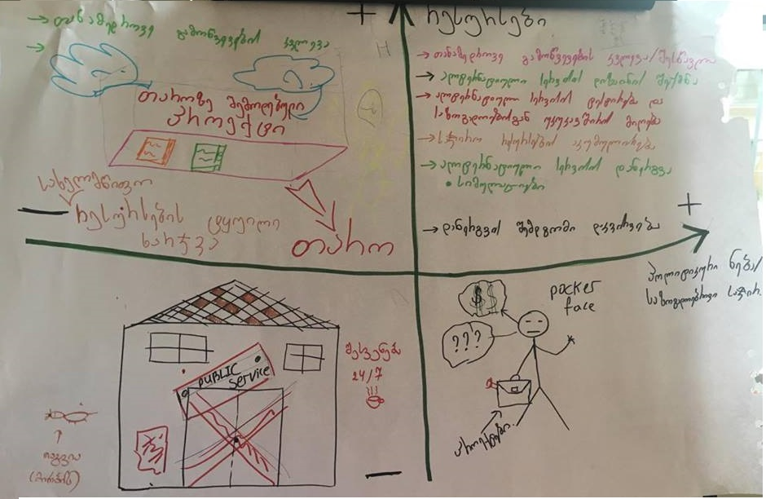

**Topic: How do you abandon public services that no longer meet modern needs?**

**Driving forces: Resources and Political Will**

**Scenario A:** High resources  and low political will

Research on modern challenges are constantly done and relevant project are elaborated. However, this projects end up only in the bureaucratic shelves; State resources are spent pointless.

**Scenario B**: High resources  and high political encourages

* research/study of modern challenges
* Creation of alternative design for services
* Testing and collecting feedback loops about alternative services
* Accumulation of the required resources
* Launching of alternative services using
* Simulations to see how scenarios play-out
* Observation after launch to improve implementation

**Scenario C**: Low resources  and high political will

Poker face guy wearing suitcase written “projects”. And is always looking for money (donors and support)

**Scenario D**: Low resources  and low political will

No public services. There is break time 24/7

|  |
| --- |
| Topic 3: Fostering agility to support effectiveness of the public sector  Driving force: Finance and Management support  Scenario A: High finances and low Management support  • Middle quality services; Lack of motivation  • Public sector is stable (not improving)  A scenario where there is waste of taxpayers money; unnecessary spending, budget could not reach those who really needs help; poor becoming poorer and the rich much richer.  Scenario B: High finances and high Management support  • High quality services ,Satisfied citizen/customer  • Flexible environment/system  A scenario where public services are transparent with integrity - with qualified personnel for civil service ensuring professionalism at all levels. High reputation resulting higher trust in public services and in turn, trusting the government.  Scenario C: Low finances and high Management support  • High motivations; Aspiration to development of public services where civil service are qualified professionals.  • Satisfied citizen  • Civil service is aspiring for effectiveness - qualified professionals  A scenario where there is trust for public services and the government leading to gaining community support and donors contributing to ensuring service delivery.  Scenario D: Low finances and low Management support  • Low quality services; High bureaucracy ; and civil staff are demotivated  • Discontent citizen  A scenario where people are frustrated with the system and would have given up. This lead to a stagnated state and eventually decline -possible riot and protest to change government. |

|  |
| --- |
| Topic 4: How do you abandon public services that no longer meet modern needs?  Driving forces: Resources and Political Will  Scenario A: High resources  and low political will  Research on modern challenges are constantly done and relevant project are elaborated. However, this projects end up only in the bureaucratic shelves; State resources are spent pointless.  Scenario B: High resources  and high political encourages   * research/study of modern challenges * Creation of alternative design for services * Testing and collecting feedback loops about alternative services * Accumulation of the required resources * Launching of alternative services using * Simulations to see how scenarios play-out * Observation after launch to improve implementation   Scenario C: Low resources  and high political will  Poker face guy wearing suitcase written “projects”. And is always looking for money (donors and support)  Scenario D: Low resources  and low political will  No public services. There is break time 24/7 |

|  |
| --- |
| Topic 5: Preparing to meet workforce planning challenges  Driving forces: Budget/funding and Structure of organisation  Scenario A: High funding and Rigid & Bureaucratic  High staff turnover due to rigidity. Money becomes a motivator.  Lack of innovative ideas/projects resulting fewer opportunities for new development and application of skills.  Systems become slow due to lack of change and reform.  Risk of personal corrections and nepotism in promotion and staff evaluation.  Scenario B: High funding and Agile & flexible  Highly motivated staff, further attracting more qualified staff bringing new innovative ideas/projects for improvement for public sector to respond to emerging trends.  Public & Civil service becomes more efficient and effective, gains public trusts— as role model for other sectors locally and internationally.  Scenario C: Low Funding and Agile and Flexible  Agile and flexible climate nurtures visionary staff and leaders.  Such leadership encourage great ideas and innovation in public and civil service delivery resulting a more satisfied society and gain more trust for public services and the government in general. This creates a good environment to work in the government.  Scenario D: Low Funding and Rigid & Bureaucratic  There is no budget to do anything new or innovative. Management is rigid and transactions within and with the government is generally a hassle and frustrating, resulting high turnover. Quality of public service continues to decline causing mounting frustration among the public and people trusts on the government further declines. Working with the public sector is now no longer attractive or prestigious creating a vicious cycle of poor quality due to lack of professionalism where nepotism and corruption thrives. |

|  |
| --- |
| Topic 6: Building trust and strengthening citizen trust in public institutions  Driving forces: Resources and Public Interests/Demand  Scenario A: High resources, low public interest or demand: where services are offered but low usage leading to wasting of public resources.  Scenario B: High resources, high public interests: there will be constant development of new services with regular need assessment analyses.  Scenario C: Low resources, high public interest or demand: where services are offered but with a lack of resources, public services requires donors and public support. Part services would have to be outsourced, potentially privatised public services which means public would have to pay; charitable organisations and NGOs supporting community services .  Scenario D: Low resources, Low public interests: Public losing trust on the government. People start to abandon and not relying on government providing public services. Community schools start emerging to support needs. More and more leaving the country to pursue education elsewhere resulting brain drain |

**Foresight Gaming Systems: 2X2 SIM**

The 2X2 Scenario Matrix exercise is further expanded into a simulation gameplay: 2X2 SIM, Figure 3.

Figure 3: The 2X2 SIM: Scenario Simulation <insert here>

Each group of participations were tasked to select one of the four scenarios developed in the earlier 2X2 Scenario Matrix for this simulation game. While most planning methods start in the present and move toward the future, in this simulation, participants start with a vision and then backcast; thinking about cause and effect relationships. Backcasting creates a space to collaboration between diverse stakeholders for analysing alternative strategy pathways and realising how the actions of others affect and impact ours, and ours on theirs.

## 2X2 SIM Gameplay and Insights

The exercise began with a thorough explanation how the simulation work. Each group was closely facilitated in simulating possible actions and disruptions as each role began taking actions towards achieving their specific vision.

As the game progresses:

* the inter-connectedness of actions and reactions: participants realised that each time they put in an action, the other stakeholders would react, changing their intended course of actions requiring re-strategizing their next move;
* the inter-connectedness of actions, reactions and change: disruptions along the way affect how things would play-out. At this point, players learn that they have to be agile in reacting to changes and quick to navigate their next move. They also learn that disruptions could bring opportune moments for new initiatives. The key is how to turn each disruption into opportunities to grow and develop; and
* the value of collaboration: each player now realised that they have a limited time to get to the end of the horizon in achieving their goals, hence they need to keep a clear focus on their vision, and think about how they could ride on the actions of others to get to the end. We can achieve our goals quicker working alongside others.

The game provided a space for exploration, experimenting and experiencing a typical state of non-linearity as in a real-world rather than the promise of a tradition of a predictable world of stable equilibrium. People are less willing to explore beyond their comfort zone as they were not willing to be seen as making mistakes, that there is always one right answer to every event or issue. This simulation allows a ‘safe space’ for people to make some mistakes. The simulation creates a space for participants to immerse in the complexities brought about by the interactions between game players diverse roles and events arising from the game.

Throughout the game, participants allowed themselves to step into making some mistakes through the exploration possible stakes and consequences in the implementation of the new civil law thereby giving themselves that space of “ways of seeing, making, doing and relating to others and of things becoming different than they are or were” (Bell, 2003) generating greater reflexivity in respect of the complexity of social innovations. The game, using multi agent models (Gilbert, 2004; Guyot & Shinichi, 2006, Bok & Rove, 2007), allows for experiencing and reflexivity of social dynamics, complexities and possible reactions towards a new phenomenon (the implementation of a new law) thereby cushioning to some extent the psychological disorientation resulting from the perceived and anticipated overwhelming uncertainties (Toffler, 1970) that the implementation of the new civil law brings.

* The time allocated for each exercise was sufficient for participants to understand and learn the techniques, methods and tools; and participants were engaged and diligently worked through all the exercises with a good level of understanding.
* After the simulation game participants now have a common language for discussions on developing action plans and collaborations between ministries; plus have a set of tools they can use within their departments/agencies for thorough discussions and analysis
* Most groups managed to describe the characteristics of each scenario but lack the ability to articulate how each scenario would play out - building the narrative for a story of the scenario. This is not surprising as Scenario Planning was new to most participants.
* Participants were assigned a typical topic on public service to lead them to thinking how the Civil Law Reform would address them. The limited time allocated for the exercise was only sufficient for them to think through each scenario and have not the chance to really think about how the civil service would address issues raised.
* A few participants were able master the technique at the same time map their thinking onto how the new Civil Law could be implemented.
* During the group report back at the end of the exercise, there were a few instances of in-depth discussions between officials about what the law was about and what they (respective departments) have done when drafting the law.
* The 2X2 Matrix simulation provided a space for engaged discussions on some of the concerns of the law coming in force based on some feedback from participants:

*“Event was effective. The plan to sit together state entities and non-governmental organizations worked well as well as opinion sharing on public services and civil service.”*

*“Considering the ongoing changes, it is very important to plan such activities in the future, for opinion hearing and discussions”*

*“My recommendation to Bureau would to have more communication with the public entities, because as the event has identified, most of the public servants did not have information about new law on service law”  
“In this concrete case Foresight was used post-factum as the new law will enter into force since July 1st. Despite this, I think Bureau as well as other public entities will more actively use this methodology for planning future changes and by doing this will make their work more effective”*

*“To increase involvement of other stakeholders by expanding interest and level of awareness during the elaboration process.”*

The ServiceLab Moving Forward

* Build a plan of action with key partners for developing further foresight capacity; and
* identify strategic opportunities to use foresight approach and experiment with tools and methods where needed.

Conclusion

This event was considered by UNDP as an innovative approach for civil service capacity development. The Conference was structured to achieve two broad objectives: to enhance decision making and planning capacities of civil officers and to provide a platform to raise awareness and understanding of the new law and to initiate an early discussions on associated implementation issues. Overall, based on the findings of the post-workshop survey (see Figure 4), participants found foresight methodology and scenario simulation allows for participative discourse amongst diverse stakeholders; the exploration and experiencing the implications and effects of the new civil law before they come into being; and facilitates the stretching of thinking, the framing and re-framing of imaginings of public service and its future; evidently, useful in supporting and encouraging the thinking of and the planning for the new law coming in force.

Figure 4: Post Conference Survey Findings <insert here>

Foresight methodology can help foster an agile and effective course of action driven by participatory insights and a forward-looking perspective. There are multiple case studies and exemplar governments around the world successfully using strategic foresight in facilitating decision making, policy, planning and strategy development processes (see among many e.g. Centre for Strategic Futures Singapore, 2013; Africa Foresight Exchange, 2015; UNDP Global Centre for Public Service Excellence, 2015; Althaus, 2016; Singapore Cooperation Programme, 2017). Civil officials need “foresight skills to understand potential future scenarios to find solutions that are future proof”; they need skill-sets “to ensure policy is future oriented and sustainable” and “to rethink tools and processes of the policy making itself” (OECD, 2017; p35).

Policy, planning and strategy development process framework (Figure 5) summarises the use of foresight methodology in civil service, can be used to monitor progress, shift priorities when needed, identify new challenges and opportunities on the horizon, and develop the capacity to use foresight for adaptive strategy enhancement and fulfillments. This process should continue throughout the life of the strategy and can serve to renew or shift priorities as well as generate valuable insights along the way. The two-day conference did not provide sufficient time to cover exercises for the entire six stages as depicted in the framework but adequately advanced an understanding and the usefulness of foresight for decision making and policy development and implementation in civil service.

Figure 5: UNDP Policy Planning and Strategy Development Processes <insert here>

# References

Africa Foresight Xchange (2015) Foresight in the public sector. Retrieved from http://www.cpsi.co.za/wp-content/uploads/2015/11/GCPSE_Africa-foresightXchange_30-11-2015.pdf

Althaus, C. (2016). Strategic foresight and the future of the public service: Imagination and disruption. Retrieved from https://www.anzsog.edu.au/resource-library/news-media/strategic-foresight-and-the-future-of-the-public-service-imagination-and-disruption

Bok, B. M. and Ruve, S. (2007). Experiential foresight: Participative simulation enables social reflexivity in a complex world.  *Journal of Futures Studies, November, 12(2):* 111-120.

Centre for Strategic Futures Singapore (2015). Foresight and public policy conference. Retrieved from https://www.csf.gov.sg/docs/default-source/default-document-library/psd-foresight-conference-2013.pdf

Gilbert, N. (2004). Agent-based social simulation: Dealing with complexity. Centre for Research in Social Simulation. University of Surrey, UK. Retrieved from http://cress.soc.surrey.ac.uk/resources/ABSS%20-%20dealing%20with%20complexity-1-1.pdf

Guyot, P. & Shinichi H. (2006). Agent-based participatory simulations: Merging multi-agent systems and role playing games. *Journal of Artificial Societies and Social Simulation, 9(4).* Retrieved from http://jasss.soc.surrey.ac.uk/9/4/8.html

Hayek, F. (1994). The Theory of Complex Phenomena. in M. Martin and L.C. McIntyre (ed.), *Readings in the Philosophy of Social Science*. Bradford Book: MIT Press. Cambridge, Massachusetts. (Original work published 1961)

Ibn Khaldun (1958). The Muqaddima: *An Introduction to History*, trans. from Arabic by Franz Rosenthal, 3 vols., Bollingen Series, No. 43. New York: Pantheon.

Kauffman, D. (1976). *Teaching the future: A guide to future-oriented education*. ETC Publications.

Kolb, D.A., Boyatzis, R.E., and Mainemelis, C. (2000). Experiential learning theory: Previous research and new directions. In R.J. Sternberg and L.F. Zhang (Eds), *Perspectives on cognitive, learning and thinking styles*. Hillsdale, NJ: Erlbaum.

Lakoff, G. and Johnsen, M. (2003). *Metaphors we live by.* The University of Chicago Press, London.

OECD (2017). *OECD Skills for a High Performing Civil Service*. Public Governance Review, OECD Publishing, Paris.

Polak, F. (1973). *The Image of the Future*. Translated and abridged by Elise Boulding. Elsevier Scientific Publishing, Amsterdam.

Seymour, P. (1996). An exploration in the space of mathematics educations, *International Journal of Computers for Mathematical Learning*, *Vol 1(1),* pp 95-123.

Singapore Cooperation Programme (2017). Strategic Leadership and Foresight in Civil Service. Retrieved from http://www.mpac.gov.tt/sites/default/files/file_upload/psacourses/sidstec/GIB_Strategic%20Leadership%20and%20Foresight%2014%20to%2018%20Aug%202017.pdf

Toffler, A. (1970). *Future Shock.* New York:Random House.

UNDP Global Centre for Public Excellence (2015). Foresight in public service. Retrieved from http://www.cpsi.co.za/wp-content/uploads/2015/07/ForesightInPS11Jun20151.pdf

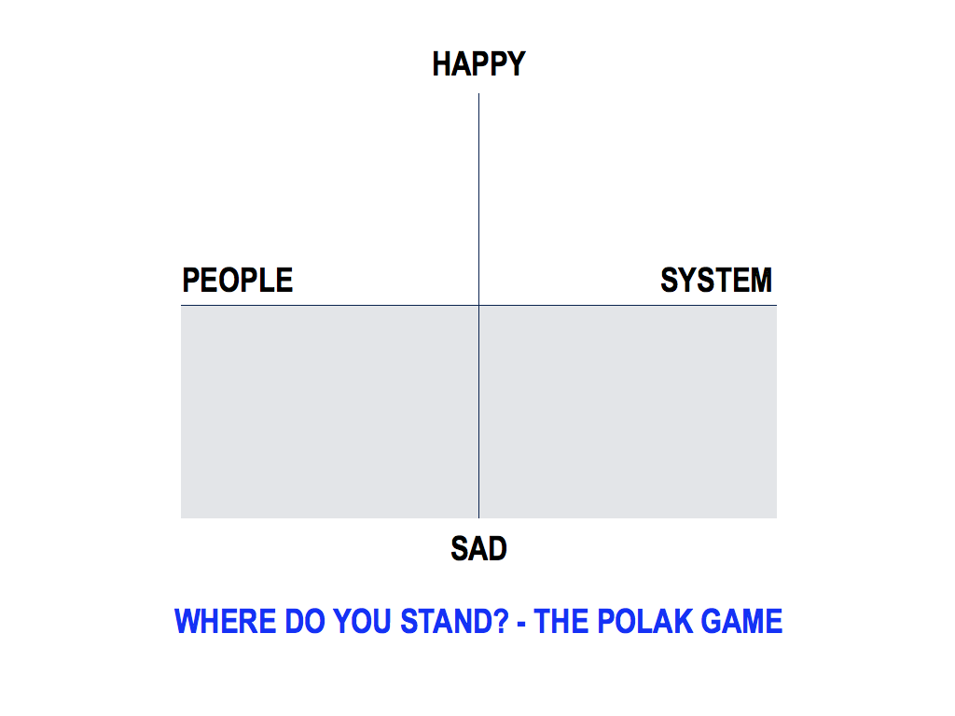

Figure 1: Where do you stand? - The Polak Game

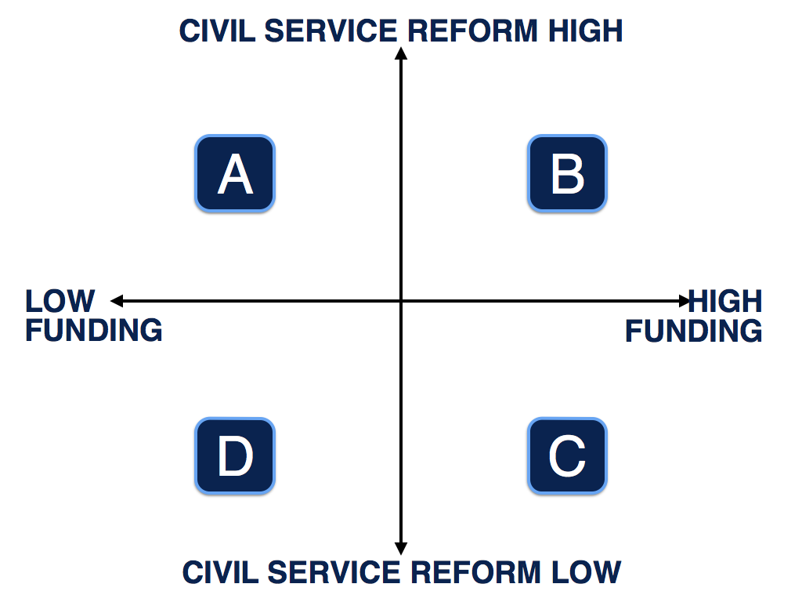

Figure 2: The 2X2 Matrix

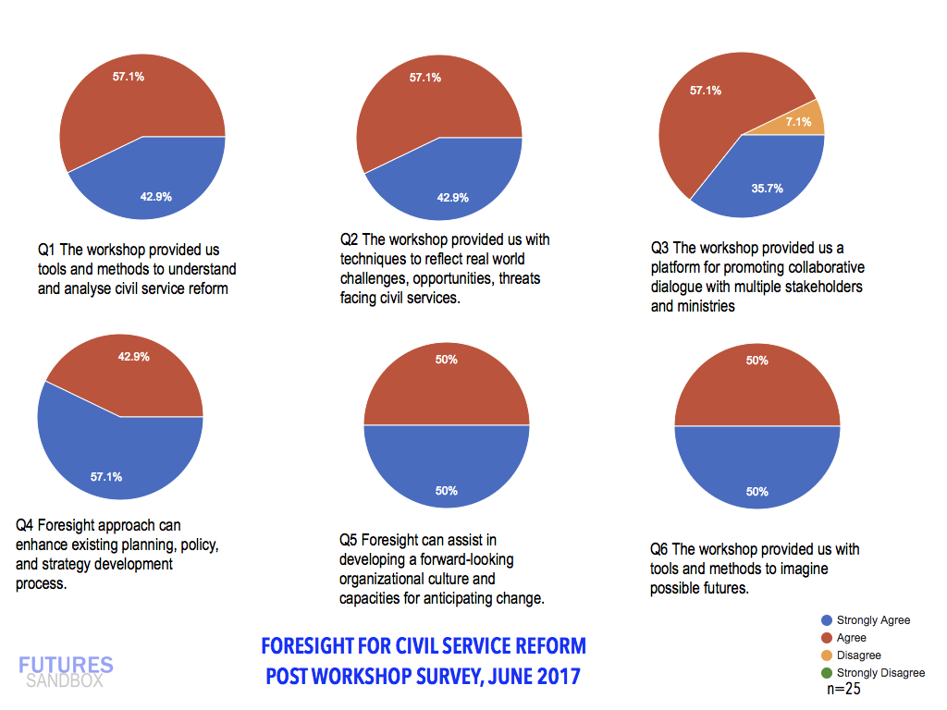

Figure 4: Post Conference Survey Findings

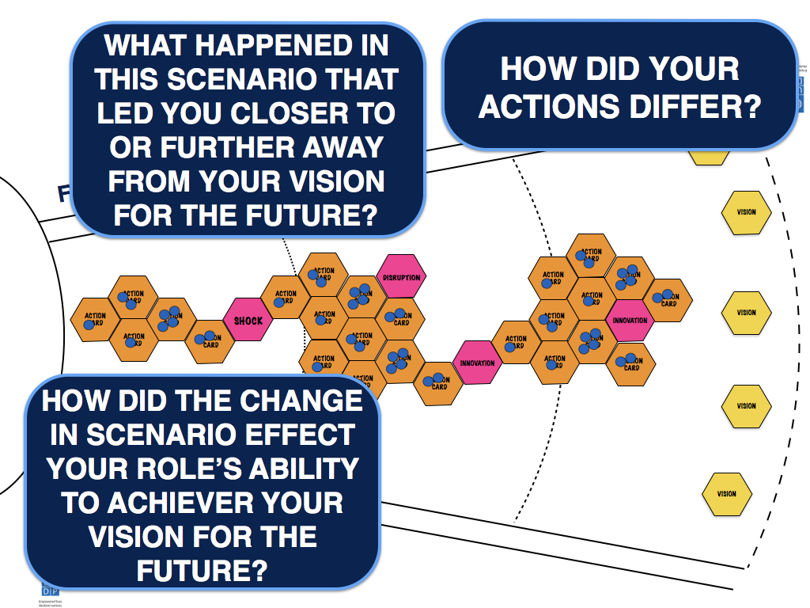

Figure 3: The 2X2 SIM: Scenario Simulation

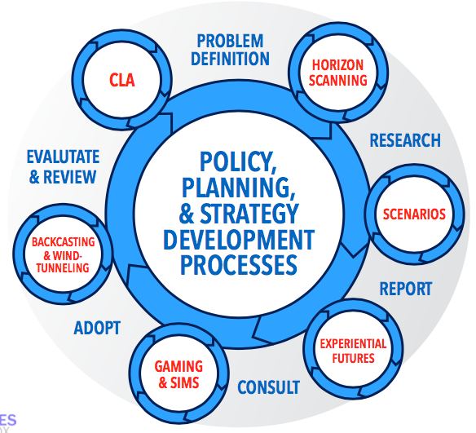

Figure 5: UNDP Policy Planning and Strategy Development Processes Framework

1) SCANNING for Trends and Emerging Issues to uncover

possibilities for what might lie ahead;

2) CHALLENGING your assumptions using methods such as 2X2 scenario matrix;

3) EXPERIENTIAL FUTURES narrate the stories of each possible scenario to get a ‘feel’ about how the situation might play-out

4) GAMING & SIM your preferred future using games such as 2X2 SIM to simulate actions, reactions and disruptions in real settings extending experiential futures in collaborative dialogues with diverse stakeholders.

5) BACKCASTING & WINDTUNNELING the key challenges, opportunities, actions, and partnerships that will help you achieve your preferred future using a method such as Backcasting;

6) Causal Layer Analysis: ANTICIPATE change, ACT as required, and ANALYSE your progress through result-driven evaluation metrics.